Marwadi University
Faculty of Computer Applications

BCA 4E Python CSE Exam

Enrollment No: 92400527299
Name: Somu Maity
Class: 4E
Date: 03-04-2026

Question -
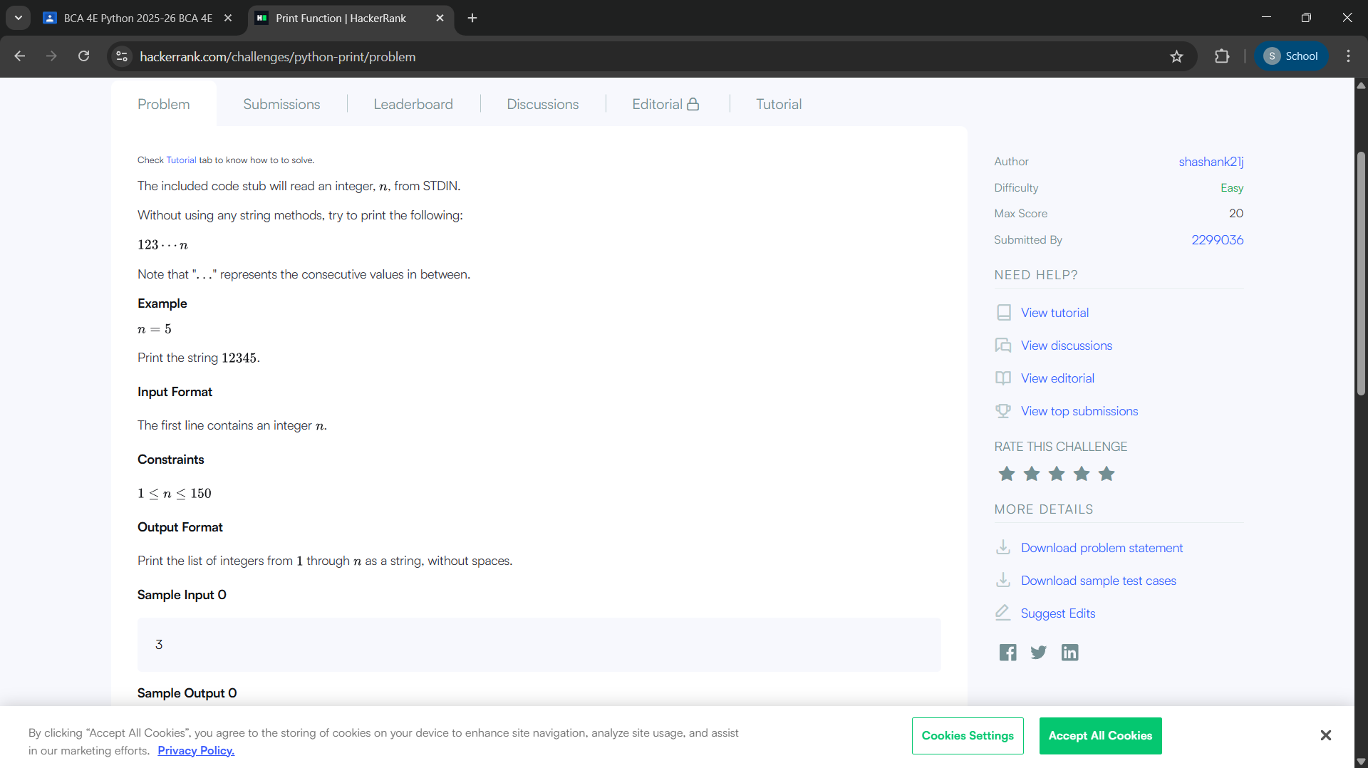
Solution –
